**FULL SUBTRACTOR USING NAND GATES**

**EXP NO.8:**

AIM: To show the working of full subtractor of nand gates only using logisim.

Truth table:

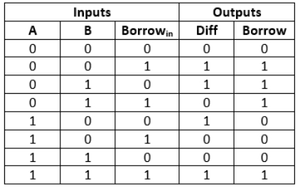

OUTPUT:

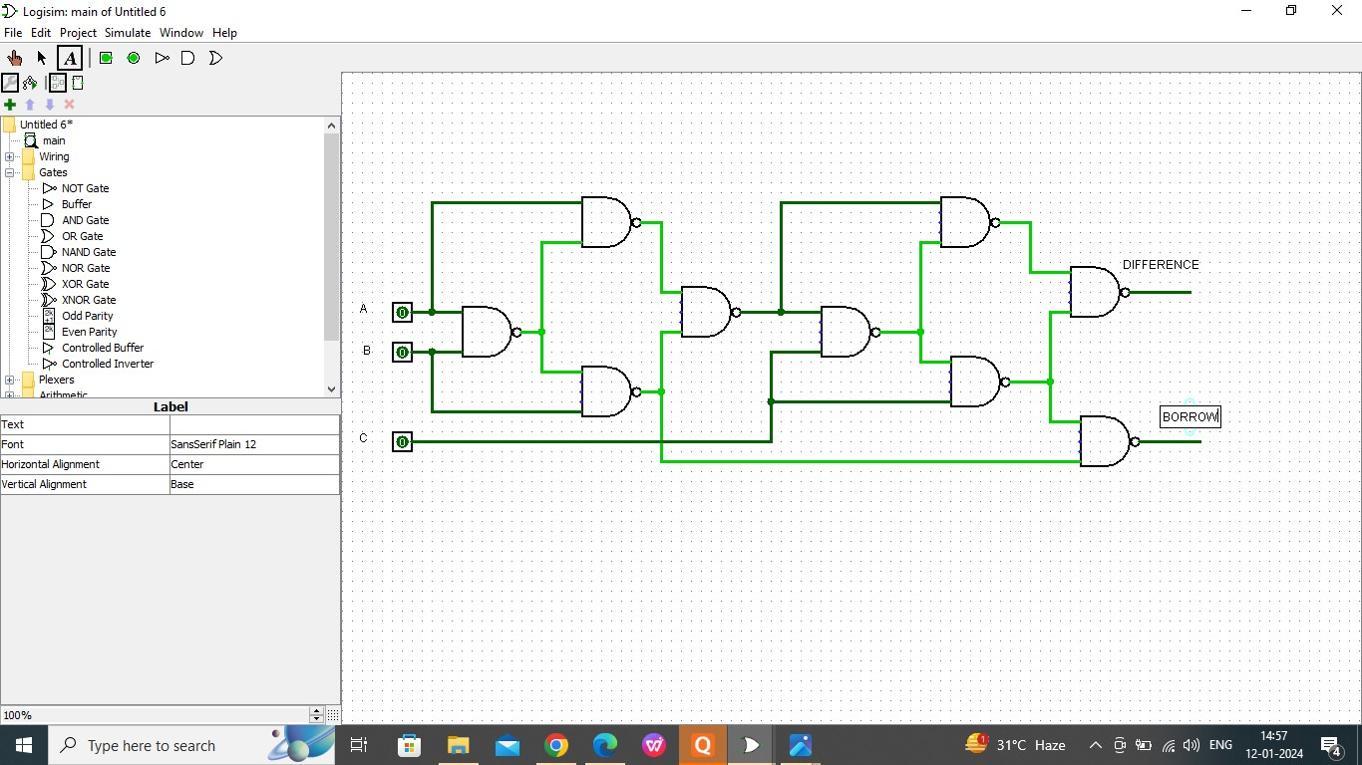

RESULT:

Thus the working of full subtractorr has been observed successfully using logisim.